Newstead Terraces News
December 2016

The Christmas festive season is a traditional time for residents to come together with family and friends to celebrate. While the celebrations are often a relaxed and enjoyable occasions, there are times when the sociable atmosphere and presence of alcohol can lead to risky behaviours’ and can at times get out of hand. In a strata environment, there are extra considerations to be made due to the close vicinity of homes to each other and use of common facilities.

In any private home, it’s the resident responsibility to ensure the health, safety and welfare of guests is maintained during any event – as well as making sure everyone has a good time.
When hosting an event in a strata scheme, there are also by-laws to consider which are in place to maintain harmonious community living and are the responsibility of the resident to personally ensure that they and their guests comply at all times.
If you are hosting a Christmas party this season, we have some handy tips to help you host a safe and enjoyable event for all:

- Check your by-laws as you can expect there will be a reference to noise, parking and use of common facilities.
- Plan your party with careful consideration of other residents and inform them of the date and time it will commence and expect to end
- If common facilities such as pool, BBQ and visitor parking areas are going to be utilised, ensure that any rules in place are followed, such as no glass in the pool area, any BBQ areas left in a tidy condition and guest only park in the designated visitor parking or on the street if required.
- If your party involves the use of a balcony, avoid overloading it with too many people. Do not allow guests to engage in excessive jumping, dancing or climbing on the balcony and make sure they do not lean on the railings or drop anything below.
- Monitor music and noise levels throughout the event being mindful other residents comfort
- Be mindful of cooking and activities that may set off the smoke alarms or pose fire risks
- Ensure any decorations are not going to be a trip or fire hazard
- Consider limiting the number of party guests and finishing your party at a reasonable hour
- If guests will be drinking, make arrangements in advance for them to get home safely
- Afterwards make sure excess rubbish from the party is disposed of correctly. All bottles and paper should be recycled. With these tips in mind, we hope this helps you have a wonderful Christmas and a safe, enjoyable and successful Christmas party!
With these tips in mind, we hope this helps you have a wonderful Christmas and a safe, enjoyable and successful Christmas party!

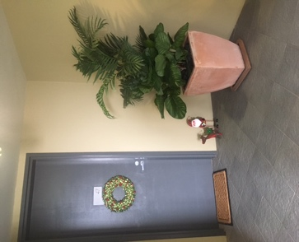 One Residents Christmas display. Thanks for sharing the Christmas Spirit U47!
Georgina Bishop
Licenced Real Estate Agent # 3428825, JP (Qual), Member REIQ, ARAMA

