Newstead Terraces News
September 2015
Hello everyone.
Next Door, Just a little bit noisy at the moment…
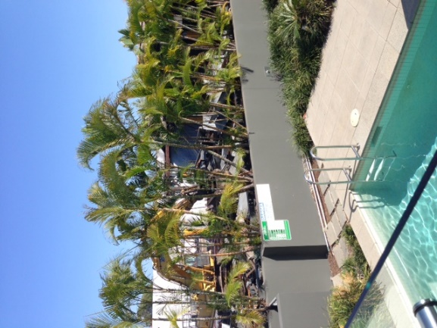
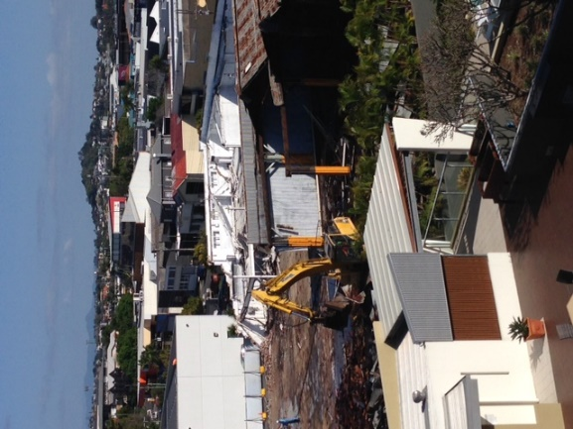
Perhaps I shouldn’t have pruned the golden canes as heavily this year! On the upside with all the extra light and space they should bush up quite quickly. Next door is looking very different, but this is just the start of the transformation.
Possum Magic
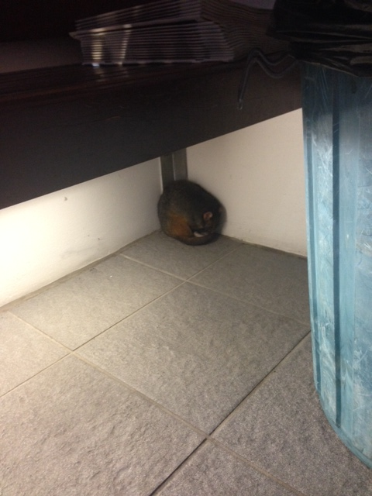
This new resident is making themselves unpopular very fast.
Responsible for repeatedly weeing on the handrails between U41 and the lift well on level 2, breaking several china pots in the courtyard of my office, leaving poos along the same courtyard wall and sleeping next to the letterboxes.
I have moved him/her out of the complex and hoped that he/she would move on, but it would seem the attraction of our five star resort style living is so appealing that he/she just keeps returning.
Any suggestions anyone? This one needs a new home and fast!

Deck Beautification update
I am so pleased to see the new lounges and umbrellas being used
by our community. The pots and plants are scheduled for installation commencing 5th October. This glorious spring weather is perfect to get out there and enjoy our newest facilities.

Keeping track of our investment!
As development in the Newstead Area surges ahead, the committee are striving to make sure that our lovely complex stays up to date and relevant in the market. Fortunately for us, we are surrounded by upmarket product and are located at the more valuable end of the street in terms of property prices and rental returns.
Here are the latest figures released by REIQ. The information comes from Core Logic RPdata and also from Membership feedback and surveys completed by people like me, at the coal face experiencing the transactions on a daily basis. I hope you find it interesting reading.
The Real Estate Institute of Queensland (REIQ) has released it sales and rentals summary for 2015.
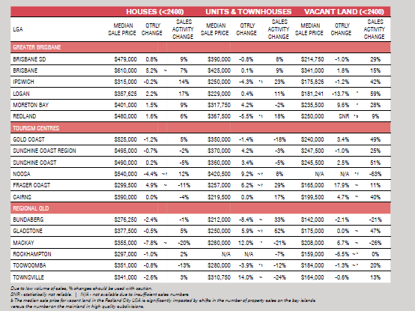

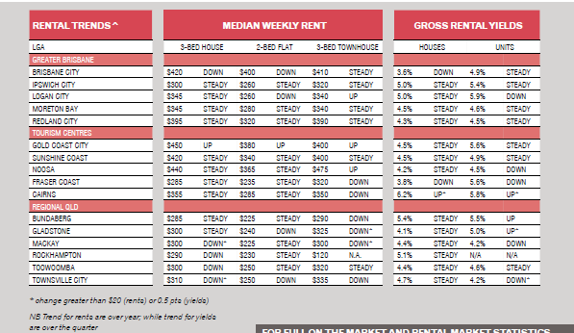

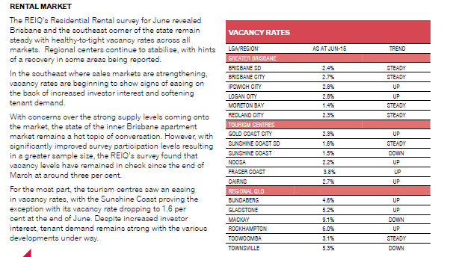

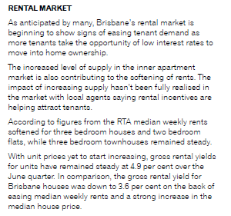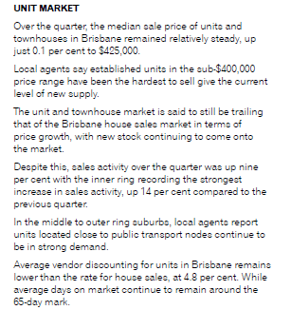

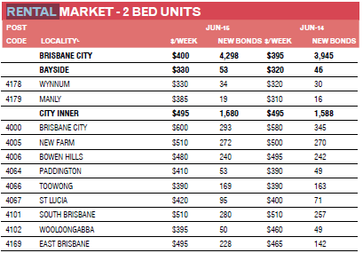

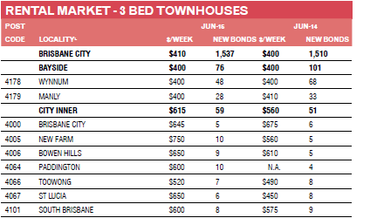
The 3 bedroom rental market has held its ground against the two bedroom market.
For those two bedroom owners, don’t despair. We have a temporary disadvantage because of the construction next door. With our investment in the common area beautification and the regular maintenance of the building, we can hold our own against the newer properties popping up all around us. I firmly believe that once the construction is over, we will go back to being able to enjoy our superior rental returns.

Hope you have enjoyed the read.
Georgina

