I hope everyone enjoyed the Easter and Anzac public holidays. I had a lovely time with the family at Noosa. Topped up the tan and did a bit of competitive ocean swimming, rested up and ready for a busy month ahead.
Congratulations to Howard and Sally (U60) on their Marriage over the Easter Break. They raced off to the Margaret River Area of Western Australia to tie the knot with family and friends joining them in a beautiful Vineyard.
We welcome Jay (U05), Donna (U24), Paul and Melanie (U34) and Scott, Brenda and Adelaide (U03) to our community this month.
The Newstead Terraces Community are planning a Winter get together for the Newstead Community, at the BBQ area. Please keep June 22nd clear. It is yet to be decided whether it will be a lunch time or evening event. More information will be posted next month.
It would seem that April is the date that the statistics are released. I have collated a few bits and pieces for your information and as a comparison basis. We all have a significant investment in Newstead Terraces and a little bit of feedback about our investment performance is never unwelcome. For those of you whom are tenants, you might like to know how your choice compares with others in the area. It is not unknown for tenants to become owners in the complex!

Rental Comparison with Local Area Averages
 | DEC 13 |  |  | DEC 12
2 Bedroom unit Av | Med Weekly  Rent $ | No of Bonds  Lodged | Yield | Med Weekly  Rent $ | No of Bonds  Lodged | Yield
4000 Inner city | 530 | 251 |  | 550 | 269
4005 New Farm | 510 | 270 |  | 500 | 243
4006 Newstead | 460 | 241 |  | 495 | 232
Newstead Terraces | 655 |  | 5.4% | 645
3 Bedroom Unit/Townh
4000 Inner City | N/A |  |  | N/A
4005 New Farm | 720 | 8 |  | 730 | 7
4006 Newstead | 510 | 9 |  | 620 | 9
Newstead Terraces, | 835 | 4 in pool | 5.7% | 785 | 7 in pool
Data Source, REIQ Property Monitor Published Statistics based on data gathered through RPDATA and REIQ surverys.
REIQ Monitor reports average Gross Yield on Rental properties in Brisbane area to be 5% for DEC 13. Brisbane Vacancy rates 2.5% and trending up, Newstead Terraces, in the Quarter from DEC 13 to March 14, maximum two weeks vacancy between signed up tenants. Time on the market:- less than 3 weeks to locate a new acceptable tenant.
To Calculate Gross Yields
2 bed apartment average sale price of $630000 and av rental return $655 a week used, 5.4%
3 bed Apartment average sale price of $750 000 and av rental return of $835 a week used 5.7%
Average Rent Achieved 2010 to 2013
 | Dec 13 | Dec 12 | Dec 11 | Dec 10
2 bed | 655 | 625 | 585 | 550
2 bed office | 665 | 645 | 615
3 bed | 835 | 785 | 700
villa | 995 | 950 | 820 | 820
Penthouses | 1000 | 950 | 840

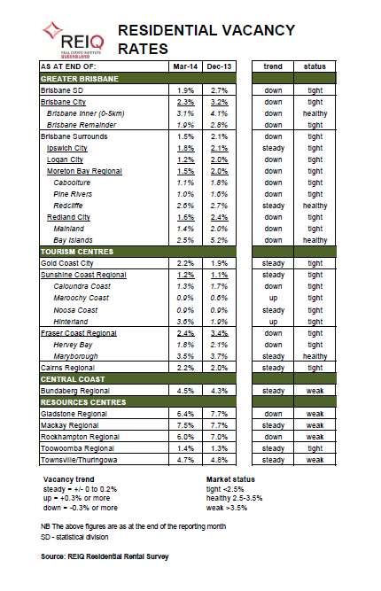

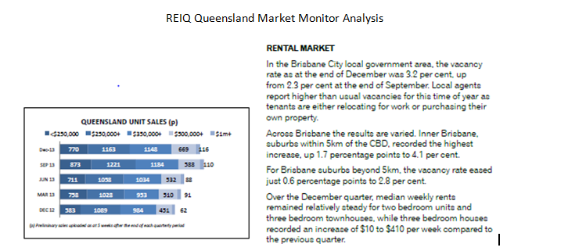

If you would like to find out the financial health of your property, try out these quick and easy to use sites:- Homeguru.com.au and ozhomevalues.com.au. Both sites over free valuations and additional interesting information about your investment.

I hope that you found the above statistics interesting and feel confident that your investment is growing and achieving the returns you hoped for. I feel even more comfortable about my decision to invest in Newstead Terraces when I get to see these sorts of comparisons.
Kind Regards
Georgina Bishop
Onsite Manager
Newstead Terraces
07 38526928

