Newstead Terraces News
September 2013
Congratulations must go to our preferred Sales Agent Robert Ferguson of Calibre Real Estate whom has managed to sell U51 in under 14 days on the market. A truly remarkable effort, that has both the owner and the buyer happy with the sale process. Once again Robert has achieved a very acceptable outcome in a remarkable timeframe. If you are thinking you might like to sell, please allow me to introduce you to Rob.
For anyone interested in a bit of spring cleaning, I have negotiated a bulk rate on blind cleaning with Amazing Clean. They will ultrasonically clean the roller blinds with a same day service. Collecting the blinds in the morning and returning that afternoon and reinstalling the blinds. I had the blinds done in Unit 1 and they came up really well. All those little squashed bugs and the dust line from where the blind usually rolls up to gone and the chains all cleaned as well. The call out fee is $70, but if three people book in on one day, they will share the call out between the three making it just $23.33 each. The three lounge room blinds are $58.50 each, and the two in the bedrooms will be much the same. A total spend of (estimated) $423.83 will bring the (7) blinds back to looking like new. The complex is coming up to 8 years old. Some blinds have not been professionally cleaned in that time frame. If you think your blinds might benefit from an ultrasonic clean, let me know and I will get groups of three arranged for you.
The really exciting news in the complex this month is the Foxtel installation. The technicians have be here three Fridays in a row, installing cabling, drilling under the road and connecting us to the high speed wiring we need. We are just waiting now for the Foxtel people to say we are good to go and the world of Foxtel IQ will finally be open to us.
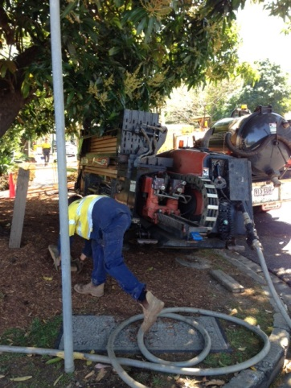
The Big machine Telstra had to try and fit in under our mango tree to install the cables.

Work has started on the stone wall facia at the front entrance to our complex. The scaffolding has been erected and the poly carbonate sheeting removed and cleaned. The next step is removing the remaining stone and putting the new finish up. There is a sign that says “Do Not Enter” outside my office. This is not because I don’t want to see anyone, but because of the danger of falling stone. If you need to see me personally, please call out to me from the lobby or buzz my door bell. We will have to be a bit inventive, but we will find each other!

Date Saver: 15th December 4.00pm
Please mark your diary and put a reminder in your phone to save some time on Sunday afternoon 15th December at 4.00pm for our annual Newstead Terraces, Christmas Drinks. The whole Newstead Terraces Community are welcome and invited to share some Christmas Good Cheer and Fellowship around the BBQ area. Please bring a plate to share and something you like to drink. Even if you can only manage to come for a few minutes, we would still love to see you.
Georgina

