Newstead Terraces News
Nov 2013
DATE CLAIMER: Newstead Terraces Residents Christmas Drinks
Sunday 15th December, BBQ area, 4-6pm.
Please bring, a plate of something nice to share, your favourite drink and a happy smile.
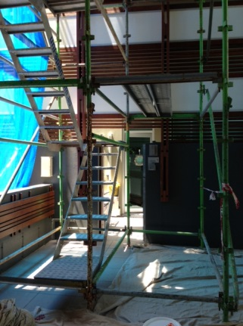
It’s beginning to feel a lot like Christmas, temperatures in the low 30’s on a regular basis, wild weather, the silly season in full swing, so it is time to consider the timing of holidays and rental payments to our landlords, and to celebrate some significant and long awaited changes at Newstead Terraces.
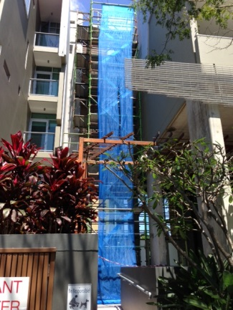
The scaffolding that has been gracing our front entrance since the last school holidays will be gone by the end of the month. The falling stone feature on the front facia has been removed and a new small stoned surface installed. The job has been rain affected, supply hindered and been a bit of a logistical effort for the contractor involved, but the end is now in sight. New Danaplon roofing will be installed once the scaffolding has been removed, freshening up the arrival experience at Newstead Terraces significantly.
View from the street
Office Entry
The timing switches on the garage ventilation systems have been identified and instruction manuals sourced. The running times have been adjusted to come on in both halves of the garage at peak times and to be off when not needed. This should realize substantial savings in electricity and improve the quality of sleep for those whose bedrooms are located beside the vents.
For those residents lucky enough to be using the pool area during the day, may we please remind you to put down the umbrellas and wrap them up safely when you have finished using them. It is storm season, and umbrellas left open during a storm will fly away, causing damage to our lovely umbrella’s but also to anything they hit in their flight path. Any one going past and noticing an unattended and open umbrella close to the end of the day, or close to a storm arriving, please feel empowered to put the umbrella down and secure it as best is possible.
Aren’t the frangipani trees beautiful at the moment? It is an absolute joy to walk through the grounds and get a waft of their fragrance as you pass.
The Christmas holidays are fast approaching and I am keenly looking forward to some time on the beach with my family. The office will be closed from Saturday 21st Dec and reopening Monday 6th Jan. For Landlords, this runs across the end of month pay period. For those of you with mortgage payments to make, I will be running the end of month payment schedule on Friday 20th Dec. This will mean that your rental return will be 10 days less than normal. The difference will be paid in January’s end of month, so Dec will be lean, Jan will be healthy.
Resident’s, we are looking forward to seeing you on the 15th for the Christmas Drinks.

