Newstead Terraces News
Jan 2013
Happy New Year. I hope that everyone had as wonderful Holiday Season as I did. It was great to spend so much time with my children at the Beach at the end of last year. Thank you everyone for being so kind to Mark and holding onto your questions and concerns until I was back at work. I really appreciate it.
We survived another round of flooding. The worst of the flooding occurred on the Australia Day holiday, not on the following Tuesday as predicted. Although the water got pretty high in Austin Street and Evelyn Street, it didn’t get as close to us as in 2011. We didn’t lose any electricity so the pumps around the perimeter of the garage coped well with seepage through the brick walls. Thanks to Paul, Michael and Brian for rescuing chairs, helping with the pool draining and pinning up fallen trees. Brisbane City Council are booked to come and sort out our fallen tree as soon as they can get to it. In the meantime, we are all ducking under the trunk when walking along the footpath. U1 and U19 are experiencing a bit more sad than normal in the meantime. We did have some water ingress, but given the force of the wind and volume of rain, it is not so surprising.

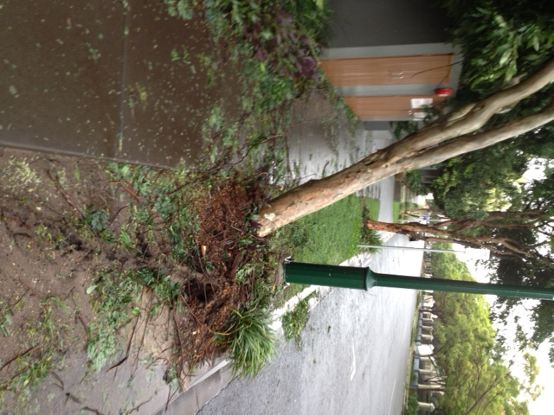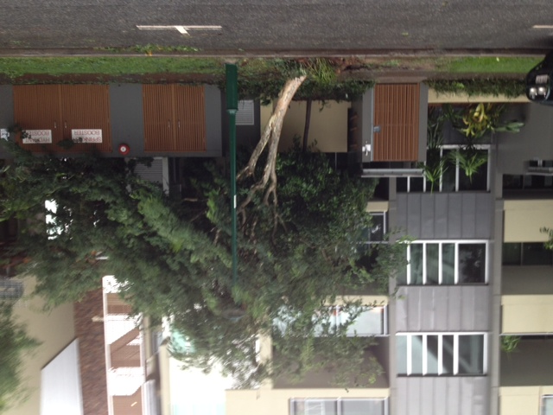
Footpath on Newstead Terrace. Leaning on U01 and U19!
There are a number of apartments for sale in the complex at the moment. If you are considering selling, please contact me. I work in conjunction with two agents, both whom have been very successful in reaching the aims of the sellers. There is a surprising amount of input required of me in the sale of an apartment, and I find it much easier to manage all the parties involved when I work with agents whom know the site and the complex, and are willing to work together to achieve the desired outcome. Good luck everyone with your sales. It will be sad to see you move on from our lovely community, but I am sure we will be welcome some lovely new residents to the complex soon.
G

