Newstead Terraces News
Feb 2013
It’s still raining! I feel a sense of de ja vu as I write this month’s newsletter. Most of the debris and damaged vegetation has now been cleaned up from the Australia Day weekend wild weather, but we have continued to experience heavy and continuous rain. The upside is that all of our storm water management systems have had a very thorough work out and any glitches in the systems have made themselves know and can be repaired.
I met with the original hydrologic engineer and our plumber last week and we have a plan to combat the constant moisture at the Western side of the Austin Street end of the garage and on the stairwell that runs along the western boundary of U18. The plumber is away working out his quotes and hopefully work can start soon on rectifying the problems there. The good news is that we have been on the right track with the work completed so far, just that there is significantly more to be done.
The gardens are thriving with all the water, and the weeds with it. Once the sun comes out I am going to have a lovely few days out in the garden encouraging the weeds to grow somewhere else. We are going to have to reapply some of the mulch. In some areas it has been over two years since the last lot of mulch was laid down and its getting a little thin. The ideal time is very soon after this rain stops so that we can trap the lovely moisture in the ground. At least I am getting some indoor jobs completed. Filling, cleaning bugs out of light fittings, scanning documents to archive etc….
For the second year in a row, the AGM was held in pouring rain. We welcome some new office bearers, Brian Porter (U33) as our new chairman and Rachel Leitch (U04) as our new secretary/treasurer. Barry Leask (U36) joins the ordinary members. We welcome back Lyn Stevens (U59), Peter Sullivan (U45) and Peter Nimmo (U57) our ex sec/treasurer and ex chairperson, has agreed to stay on and help the new team. I am certain that this team of volunteers will have a great year on the committee.
I am sure you will all agree that Peter and Kevin Yarrow (U14) immediate past chair, have done a fabulous job in running the body corporate matters on our behalves. They leave a strong financial balance and a building in good order for the next team to manage. Thank you both for your time and effort. Thanks also to Jane (U41) and Mark (U18) for their efforts during the year.
Thanks must also go to Brian Porter and Michael Doherty for their efforts rescuing trees. Here is some evidence of their handiwork performed in near gale force winds and pouring rain!!! Looks very professional!
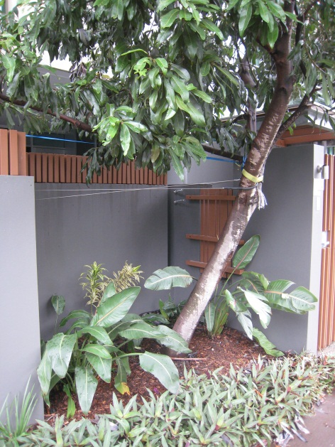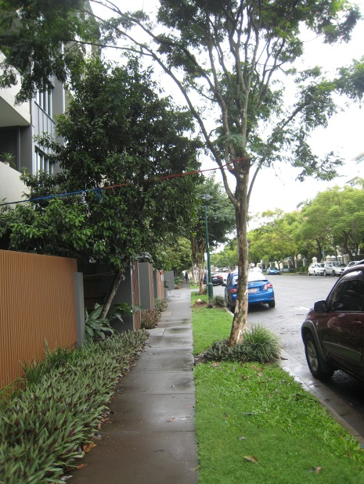

Our street scape now. A bit of a gap in the tree lined street.
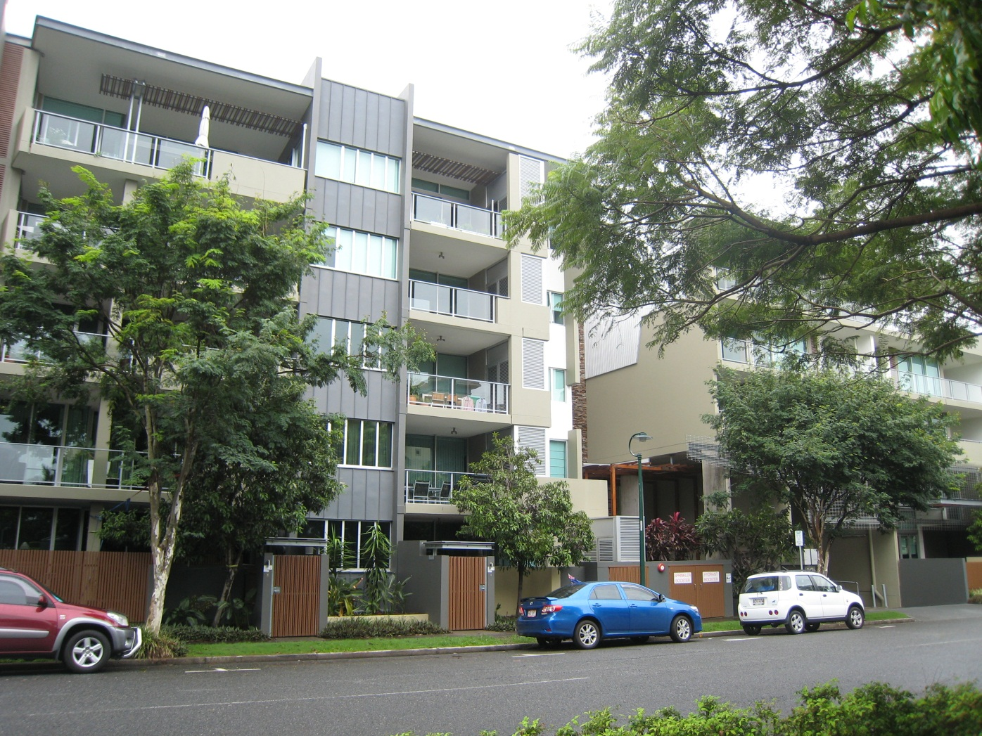
Only the smaller tree survived the ministrations of the council outside U01&U19, just a stump remains. Georgina
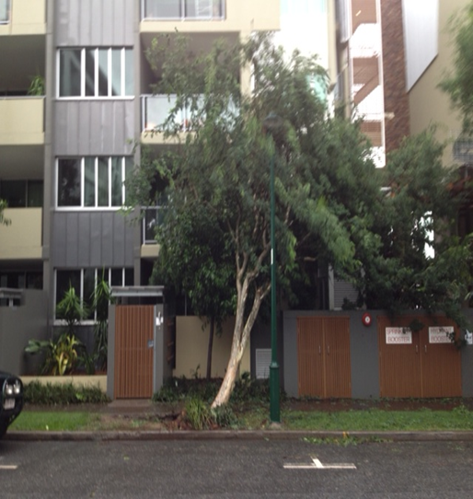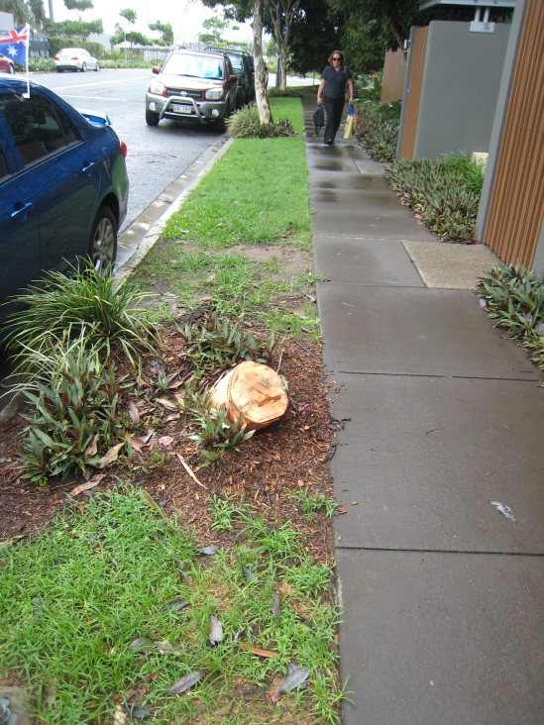
Jan 13 Feb 13

