Newstead Terraces News: June 12

Dear Owners,

Many of you have yet to meet me. I have been working at Newstead Terraces for 18 months now and I have spoken to everyone on the phone, but yet to have the pleasure of meeting some of you face to face. I hope that day is not too far away.

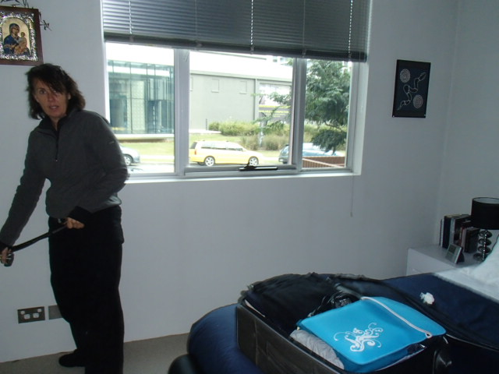
This is an action shot, snapped by John Groom for his report on the water penetration in Unit 3. Yes I am on the other end of a measuring tape. Glamorous isn’t it! The days here are varied and exciting.

Lyn Stevens commented to me the other day that she has noticed a big improvement in the calibre of tenants we have in the place now. This was music to my ears. I have been working over the last 18 months to interview and accept neighbours that we all would like to live next door to, and I think that we have a lovely mix in our community now.

Our environment has undergone some significant changes over the last 18 months, with Pier North and South and Park opening in the Mirvac complex. We have also had lovely parklands opened for public use and are now able to shortcut through this parkland to Skyring Terrace and access the new Ferry Terminal (opened in Dec) for fast trips to town via the river. The Gasworks development is powering ahead, and it will be no time at all before we will be able to work to our local Woolworths store. Terri Whites, and a fresh food precinct similar to James St markets are advertised as being part of this development. It’s good to be living in this lovely residential pocket so close to the city.

We are about to commence painting the exterior of the complex. Painters are expected to start arriving on site from July 14th. You will know from the Body Corporate minutes that OPAT were the successful bidders for the job. OPAT tell me that they will start with a small crew of tradies initially and then build slowly. This is supposed to soften the impact of the inconvenience they will cause when they are fully on site. The whole process is going to take 3-4 months. We should be able to look at our beautiful home with pride by October 30th. Trees have been pruned and cleaning has been undertaken in preparation for the big paint job.

For our landlords, I will be doing routine inspections of your properties again in August, and as we did last year, you will be invited to attend and get a look at your property. I will also be updating the PAMD20A management agreement forms, many of which are out of date. In preparation, may you please send me a copy of the cover page of your landlords insurance policy. This page should show whom you are insured with, the policy number, the date the policy expires and that you have the required third party insurance of $10 000 000.00. If you have a copy of the title to your property, that would also help in compiling the complete and updated requirements on the PAMD20A form.

Keep Warm and Dry and Well!
Georgina

